DSA

INTERNSHALA

Graphs

What is a Graph?

A graph is a non-linear data structure that consists of following two elements –

1. Nodes (vertices) : Nodes will contain data.
2. Edges : Each edge is made up of a unique pair of nodes.

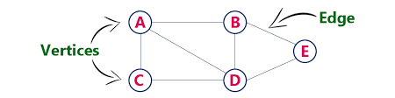

* Undirected graph

In an undirected graph all the edges are bidirectional.

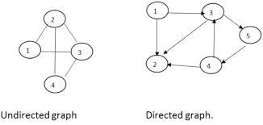

* Directed graph (Digraph)

In directed graph all the edges are unidirectional.

Loop in a directed graph

When a node has an edge to itself it is called a self-loop or buckle.

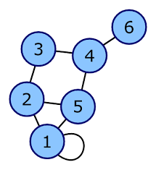

Cyclic graphs

A cyclic graph consists of a single cycle.

All the nodes are connected in a closed chain.

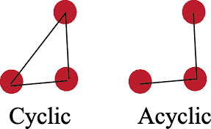

Weighted Vs. Unweighted graphs

A weight is numerical value assigned to an edge of a graph.

This numeric value is called an edge.

An unweighted graph does not have weight assigned to any edge.

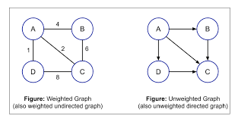

Representation through adjacent matrix

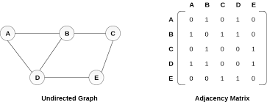

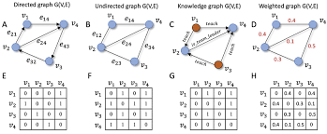

Linked representation

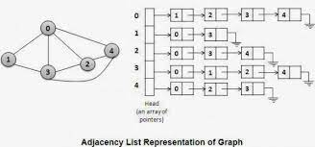

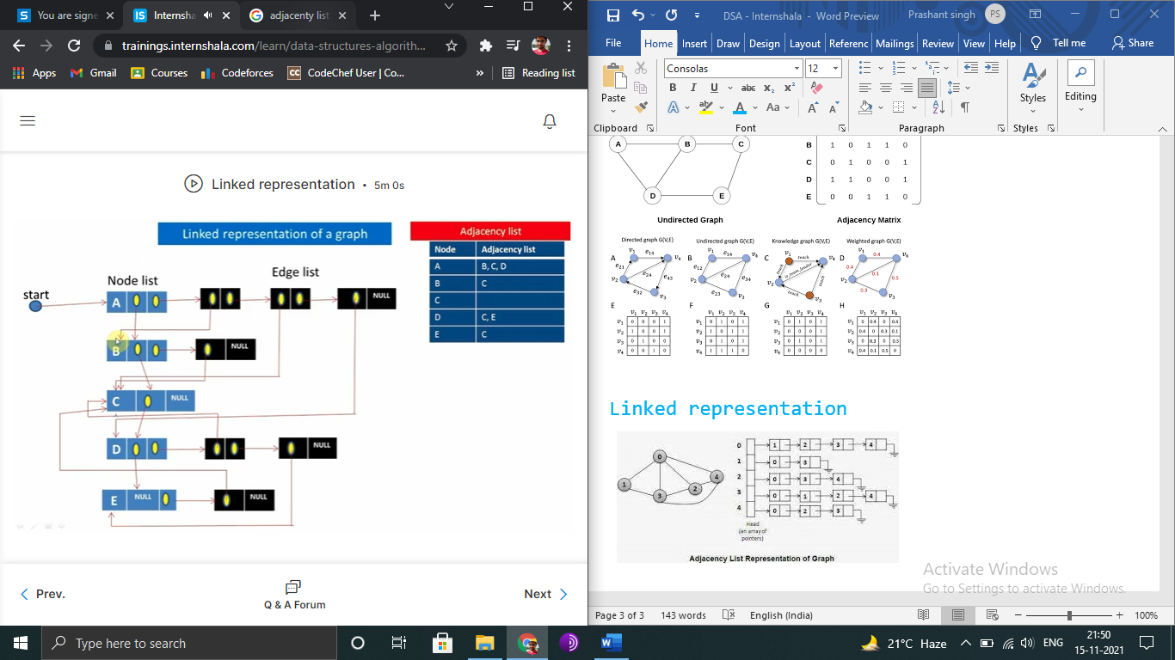

Map

* Fast key lookup data structure.
* Different from arrays where indices have to be only integers.
* Indices in maps can be of any data type.
* Indices into the elements of a map are called keys.
* Keys and associated values are stored in the map.
* Keys are always unique.

Hashing

* A file organization technique to compute unique addresses of records.
* The functions used by this technique are called hash functions.
* Popular hash functions:
  + Division/remainder method
    - Suppose we want to store records of 100 students of a university
    - Each student is assigned a 4-digit unique roll number
    - The memory pool consists of 100 2-digit addresses from 00 to 99
    - Calculating a unique address for storing record of a student with roll number 6534 –
      * Select a prime number m close to last address 99. Let m = 97
      * Find the remainder after dividing 6534 with 97.

R = 35

* + - * 35 address location is selected from the memory pool for storing the record with roll number 6534
  + Midsquare method
    - Calculating a unique address for storing record of a student with roll number 2592.
      * Square the key value 2592
      * Let s = 6718464
      * Now remove the digits from both sides of the square value so that we get a 2digit address t = 84
      * 84 address location is selected from the memory pool for storing the record with roll number 2592
  + Folding
    - Calculate unique address for roll number 8247-
      * Chop the key value into two parts and add them
      * Let c = 82+47 = 129
      * Remove the leading digit 1 as addresses are 2-digit numbers only
      * 29 address location is selected from the memory pool for storing the record with roll number 8247.